LINKEDIN PROFILE
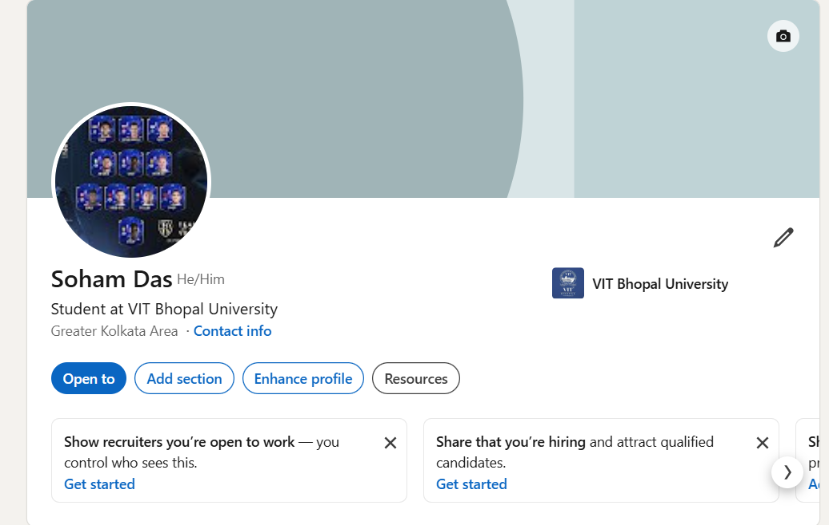
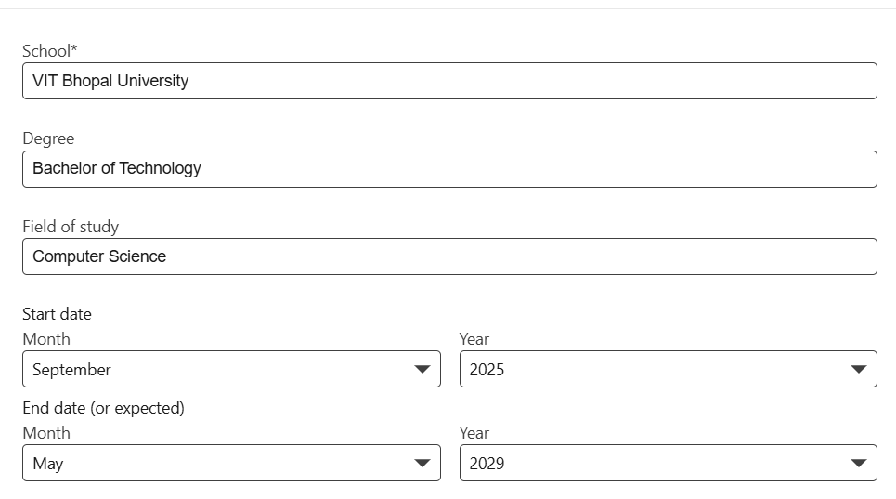
GITHUB PROFILE
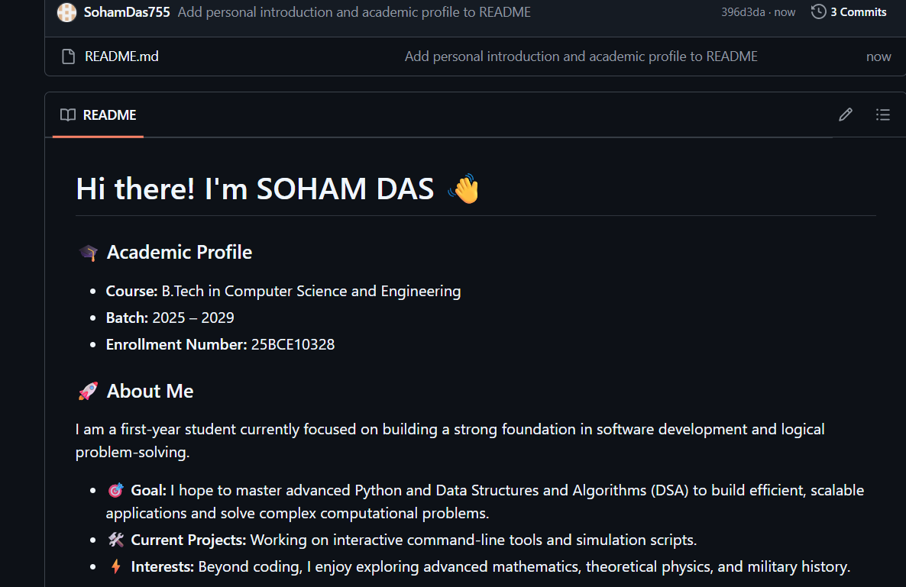
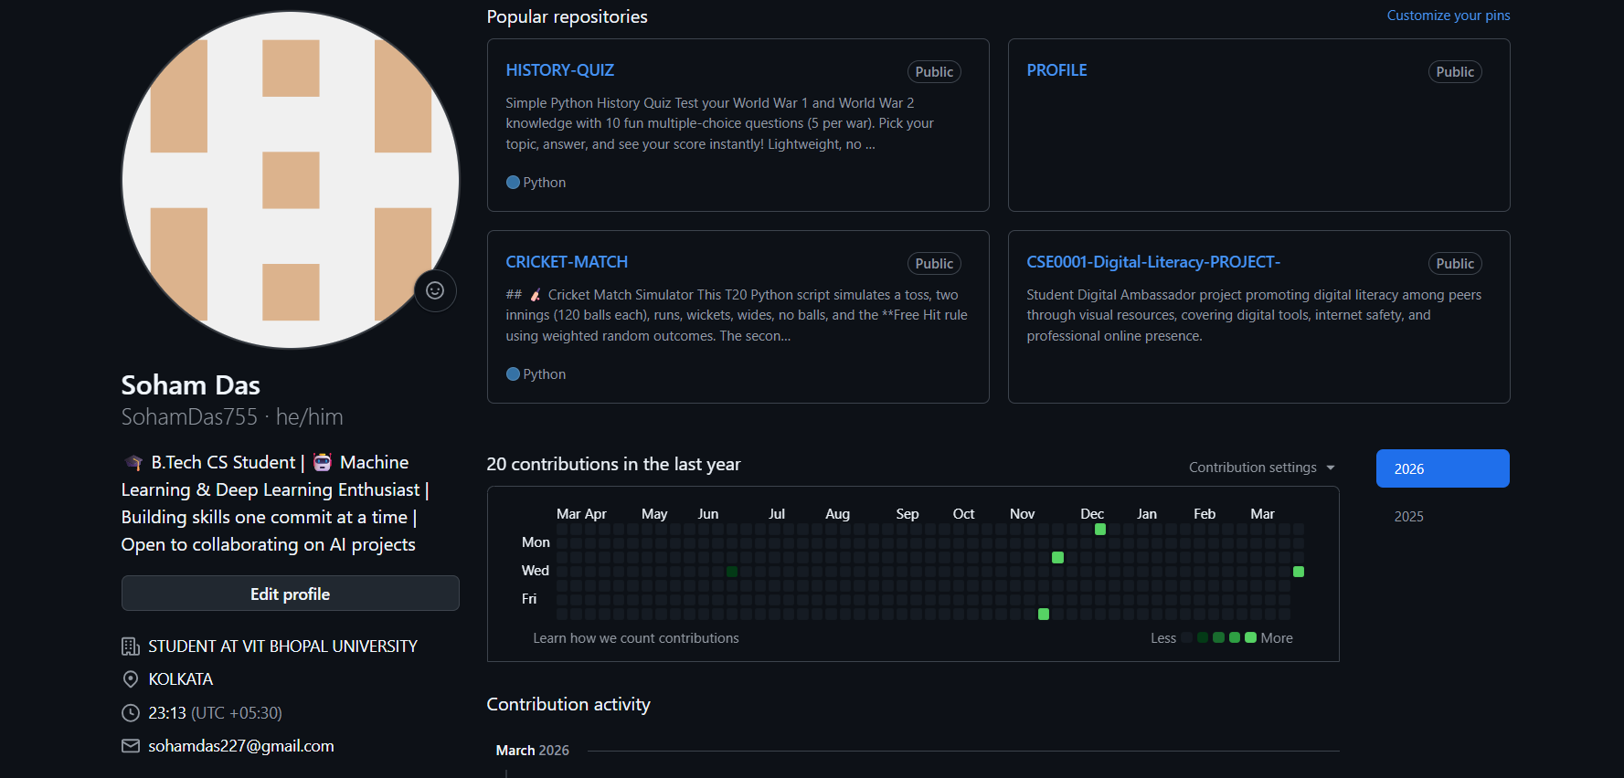
KAGGLE PROFILE
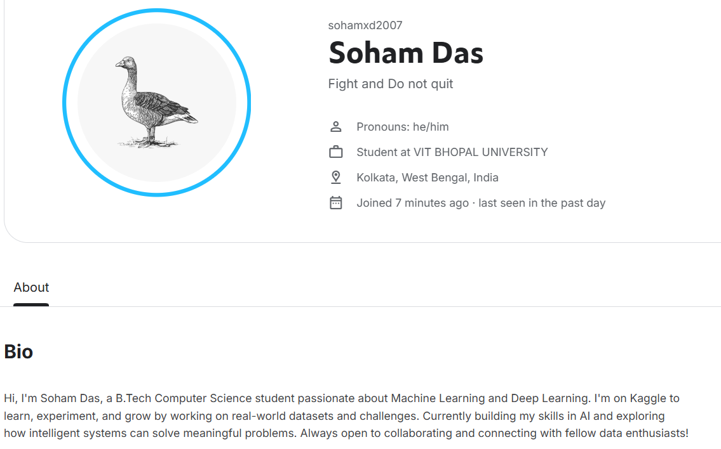

PROJECT REPORT
For building my digital presence as a B.Tech Computer Science student, I chose three platforms: GitHub, LinkedIn, and Kaggle — each serving a distinct and valuable purpose in my academic and professional journey.
GitHub is a version control and code hosting platform where developers share and collaborate on projects. I plan to use it to store my assignments, personal projects, and open-source contributions, building a visible coding portfolio over the next four years.
LinkedIn is a professional networking platform used to connect with industry professionals, share achievements, and discover opportunities. I intend to regularly update it with internships, certifications, and projects to strengthen my professional identity as I progress through my degree.
Kaggle is a data science and machine learning community platform offering datasets, competitions, and notebooks. Since I am deeply interested in ML and Deep Learning, I plan to participate in competitions, complete courses, and publish notebooks to demonstrate my practical skills.
Together, these three platforms will help me grow technically, professionally, and competitively — documenting my four-year journey from student to industry-ready engineer.

